**3rd Questionnaire Results**

**Virtual Experience: Second Test**

The second questionnaire of the user test aimed at measuring the level of immersion with physical stimulus. This physical impact were two ventilators positioned accordingly so that when the user is with its back to the mountain and facing the open landscape, it feels air blowing.

Some of the questions in this questionnaire are the same as in the first questionnaire.

For instance, questions 1 and 2 evaluated the impact of the visuals. All of them rated that the environment looked very similar to a real mountain, and 3 out of 4 stated that this made them feel more immersed (see Graphic 1 and 2).

Questions 5 and 6 asked the users about their experience with the controllers. This time, each of the users find it easy to use the controllers in a different level, ranging from 2 to 5. Half of them admit feeling more immersed thanks to it, while one of them felt neutral about it and another one didn’t feel more immersed. (See Graphic 3 and 4)

Questions 7 to 11 asked about the physical stimulus. Results show that 3 out of 4 felt the physical input, and half of them agreed it matched what they were actually seeing on VR. Besides, just one of them felt the input as something external that was not part of the experience, while another one felt it was part of the experience. The other two just felt indifferent about it. Adding to that, just one person confessed feeling more immersed because of the physical input (see Graphic 7, 8 and 9). Two people stated feeling distracted by the physical input and three considered it to be something they would actually find in a mountain. (See Graphic 10 and 11)

Regarding the questions about the sense of being immersed in the virtual environment, 3 out of 4 users felt neutral when asked if they forgot they were in a laboratory. The other one didn’t feel as such. One of the volunteers felt as he was standing on the mountain and the others felt neutral or didn’t feel like it. (See Graphics 5 and 6)

None of the volunteers felt like taking off the headset while on the VR experience and half of them felt separated from the real world. Just one person felt the sense of being in the VR world stronger than being in the real world, two were indifferent and one person disagreed (see Graphic 12 and 13). One volunteer felt events taking place around him and another one felt so involved in the environment that he forgot he was using controllers. (See Graphic 14 and 15)

We asked if they would change in any way the physical input, one said that he would adapt the “intensity of the wind every once in a while”. Another one suggested that the wind would be more effective if the room were warm, otherwise “if the room it has normal temperature it can be a little bit incomfortable”. The volunteers didn’t feel any new physical stimulus apart from the intended ones.

Finally, 3 out of 4 participants felt disappointed that the experience was over and would like to experience it again. One participant felt indifferent about both questions. (See Graphic 16 and 17)

**Graphics**

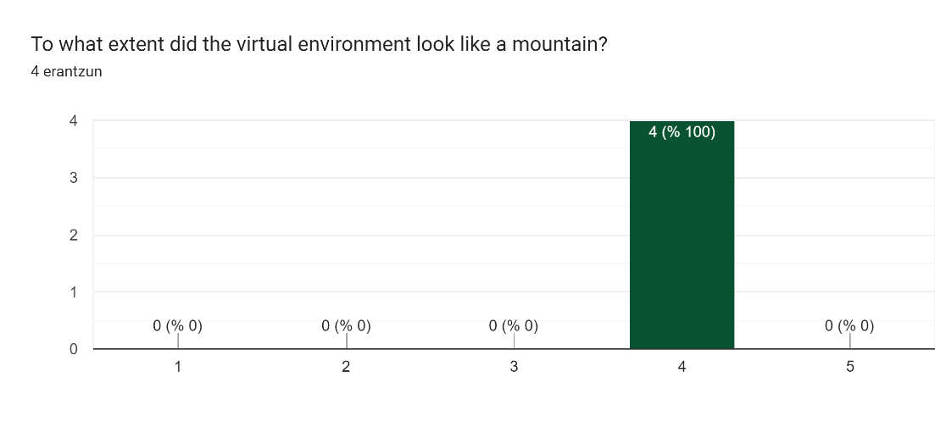

Graphic 1

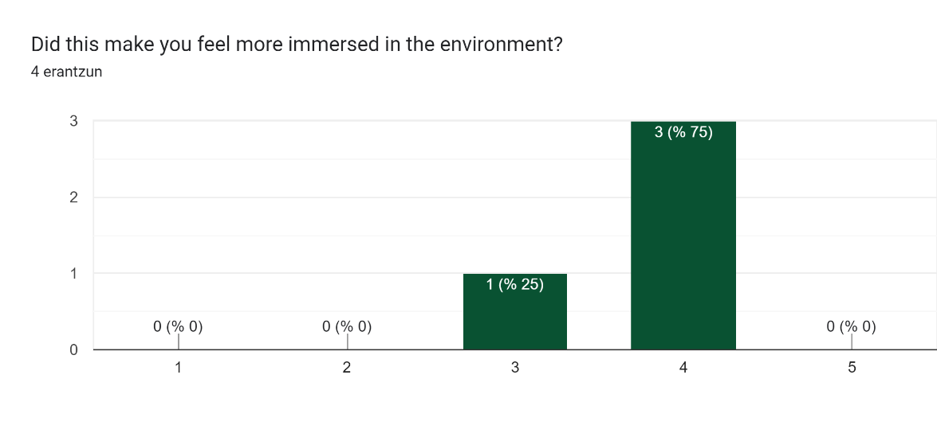

Graphic 2

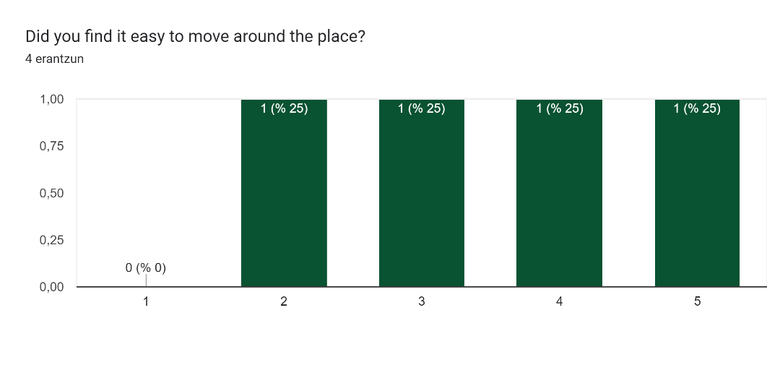

Graphic 3

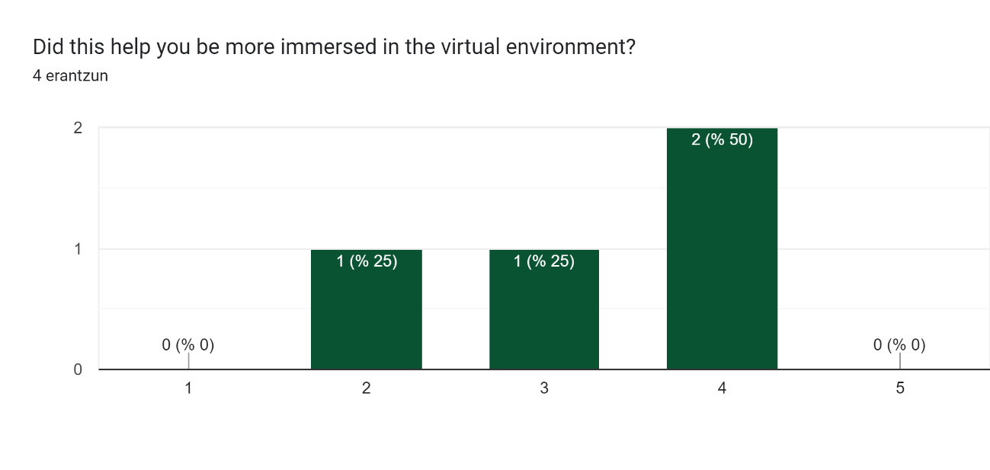

Graphic 4

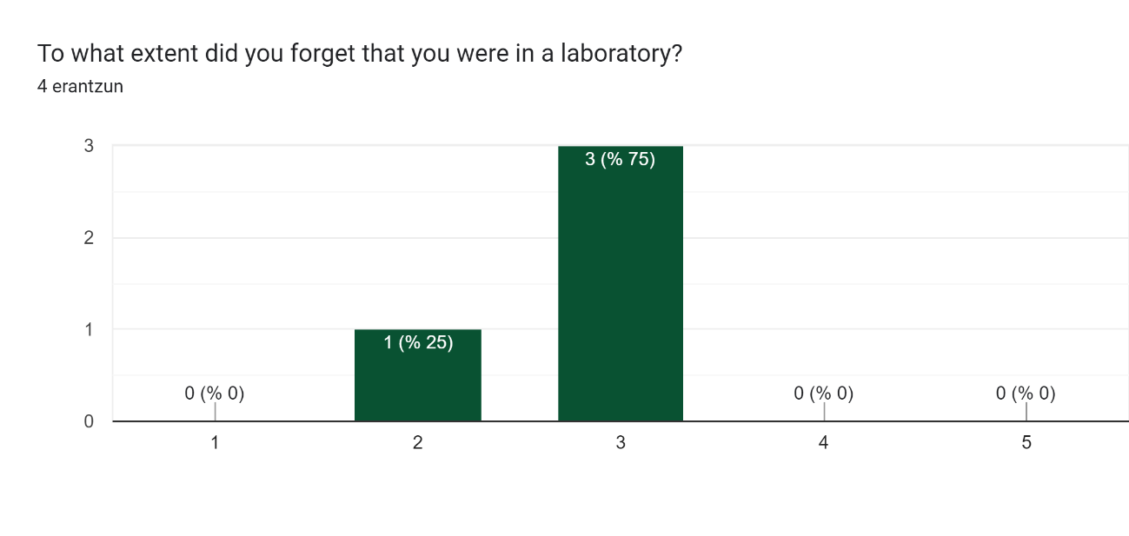

Graphic 5

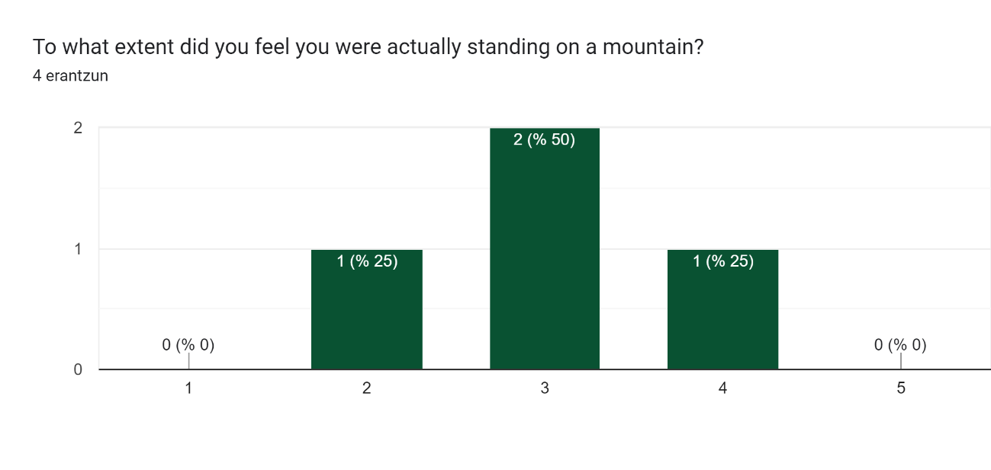

Graphic 6

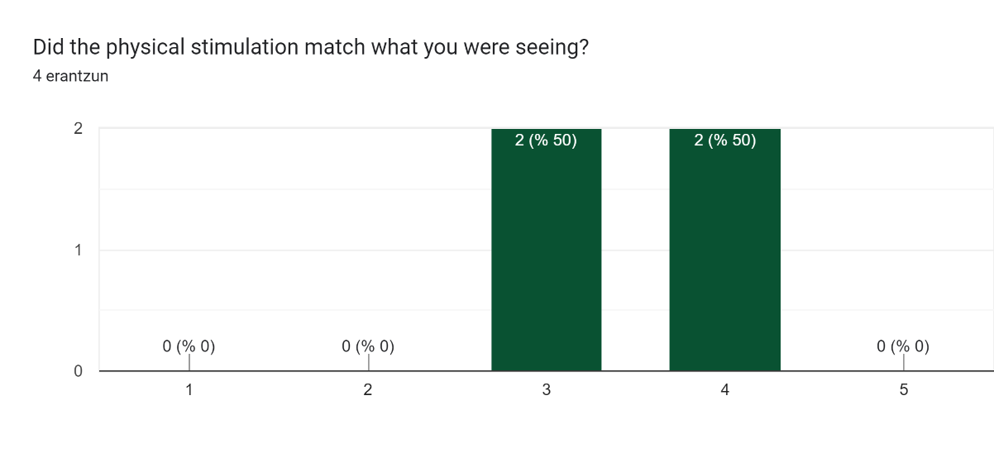

Graphic 7

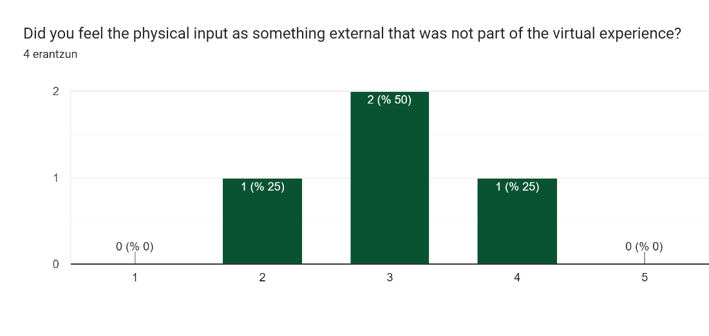

Graphic 8

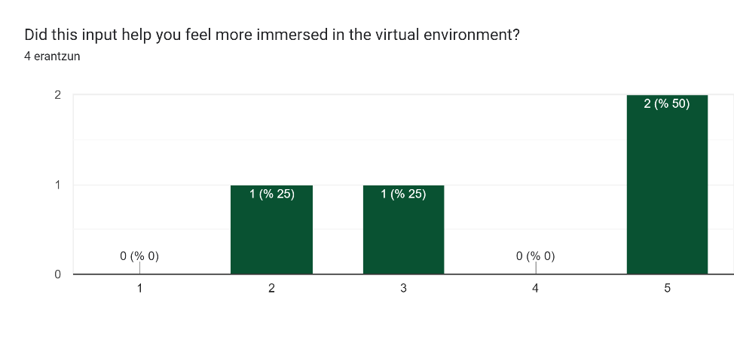

Graphic 9

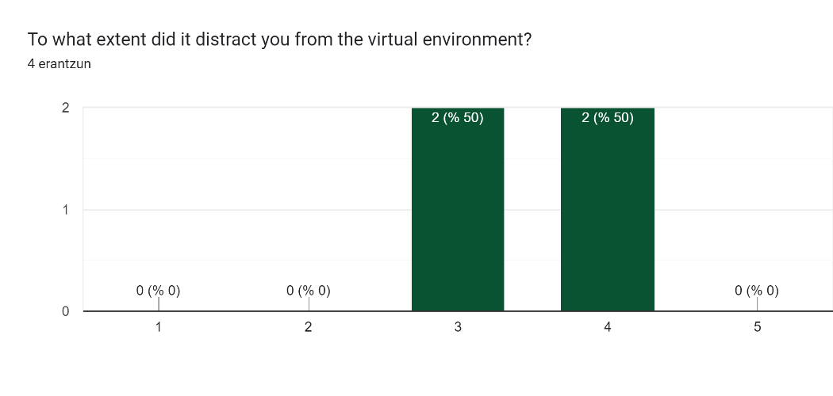

Graphic 10

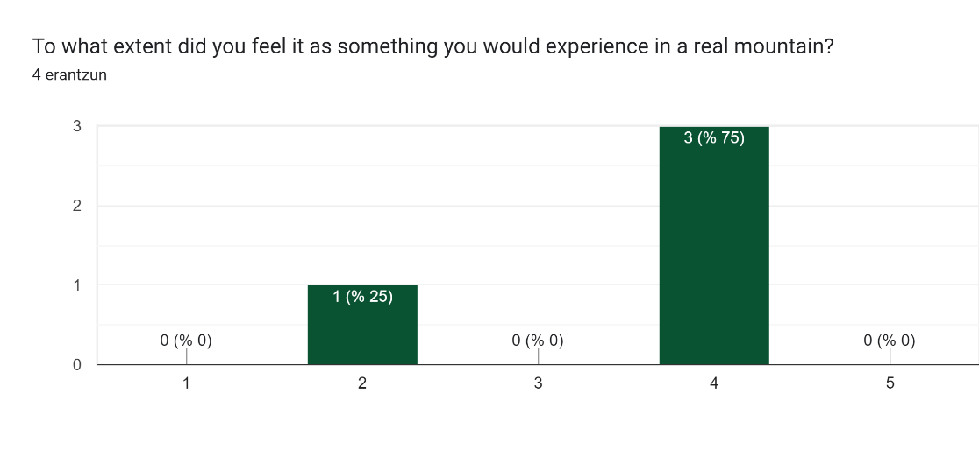

Graphic 11

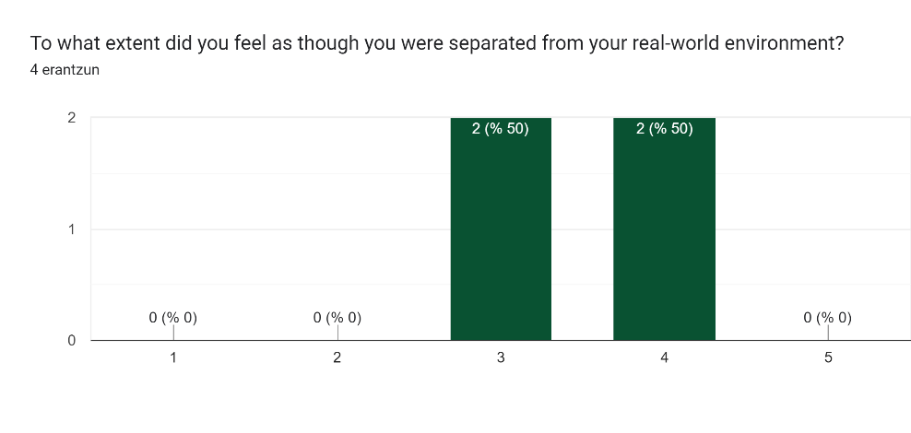

Graphic 12

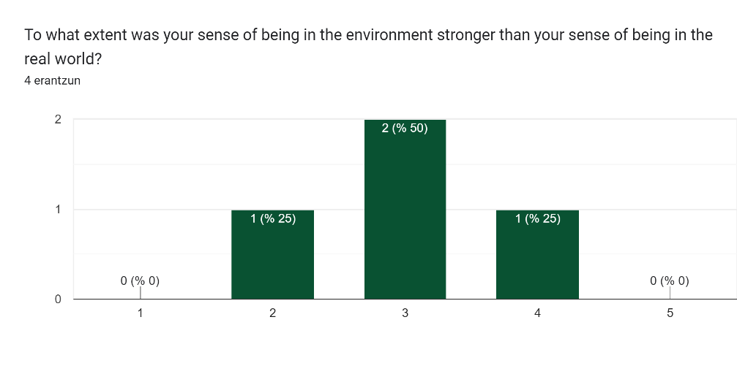

Graphic 13

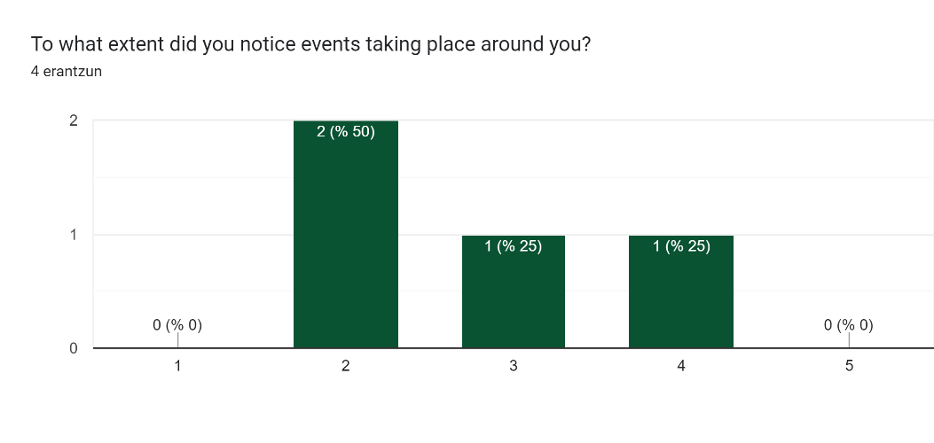

Graphic 14

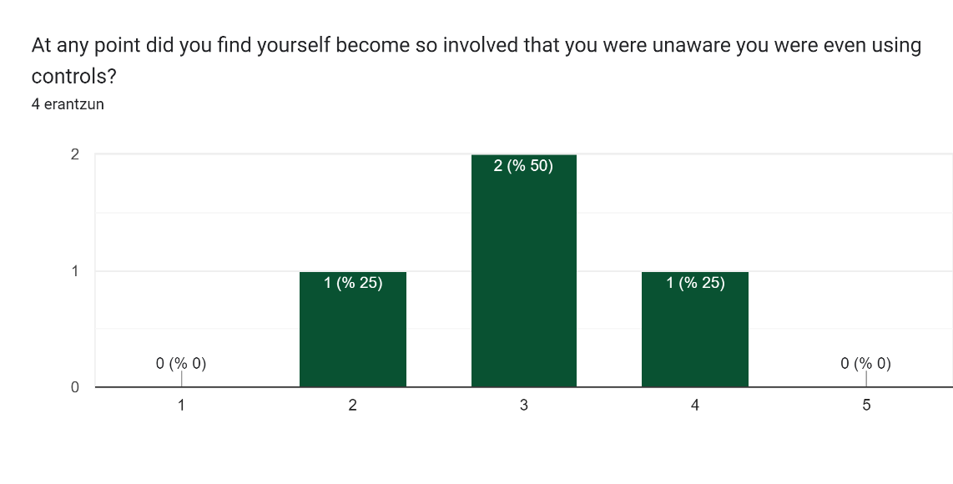

Graphic 15

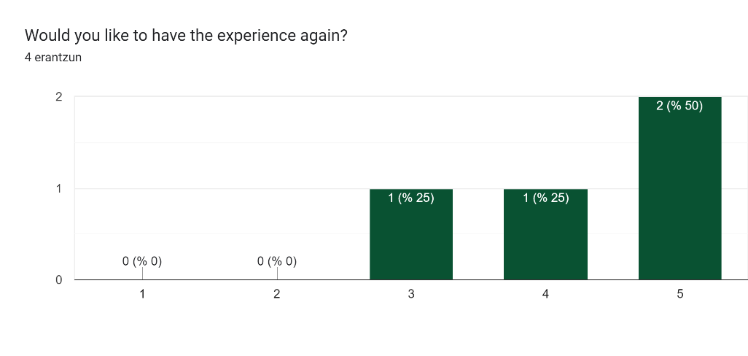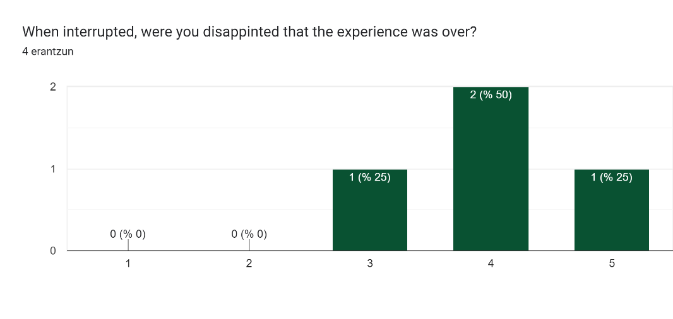

Graphic 17

Graphic 16